Date:09-10-2026
Program 4
Code:
#include <stdio.h>

int m, n, N;

int solve(int i, int j, int steps)
{
if (i < 0 || j < 0 || i >= m || j >= n)
return 1;

if (steps == 0)
return 0;

return solve(i - 1, j, steps - 1)
+ solve(i + 1, j, steps - 1)
+ solve(i, j - 1, steps - 1)
+ solve(i, j + 1, steps - 1);
}

int main()
{
int i, j;

printf("Enter m, n, N, i, j: ");
scanf("%d %d %d %d %d", &m, &n, &N, &i, &j);

printf("Output: %d\n", solve(i, j, N));

return 0;
}
Output:
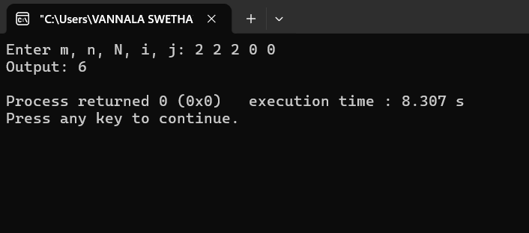

Program 5:
Code:
#include <stdio.h>

int max(int a, int b)
{
return (a > b) ? a : b;
}

int rob(int nums[], int n)
{
int a = 0, b = 0, c, i;

for (i = 0; i < n; i++)
{
c = max(a, b + nums[i]);
b = a;
a = c;
}

return a;
}

int main()
{
int n, i, nums[100], ans1, ans2;

printf("Enter number of houses: ");
scanf("%d", &n);

printf("Enter money in each house: ");
for (i = 0; i < n; i++)
scanf("%d", &nums[i]);

if (n == 1)
{
printf("Maximum money: %d\n", nums[0]);
return 0;
}

ans1 = rob(nums, n - 1);
ans2 = rob(nums + 1, n - 1);

printf("Maximum money: %d\n", max(ans1, ans2));

return 0;
}
Output: 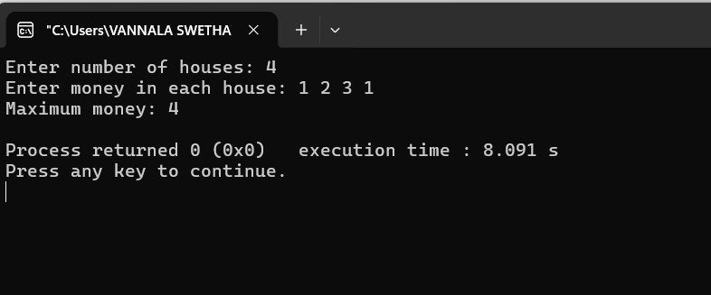

Program 6:
Code:
#include <stdio.h>

int main()
{
int n, i, a = 1, b = 1, c;

printf("Enter number of stairs: ");
scanf("%d", &n);

if (n == 0)
{
printf("Ways: 1\n");
return 0;
}

for (i = 2; i <= n; i++)
{
c = a + b;
a = b;
b = c;
}

printf("Ways: %d\n", b);

return 0;
}
Output:
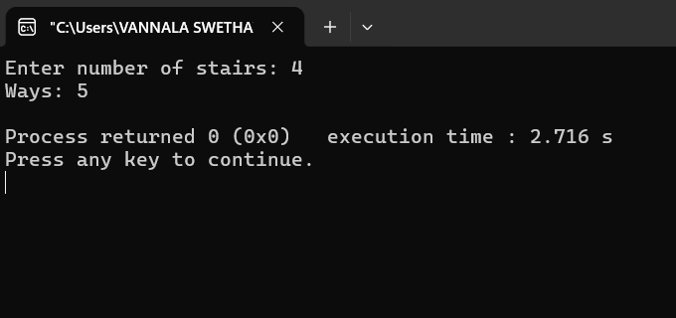

Program 7:
Code:
#include <stdio.h>

int main()
{
int m, n, i, j;
int dp[100][100];

printf("Enter rows and columns: ");
scanf("%d %d", &m, &n);

for (i = 0; i < m; i++)
{
for (j = 0; j < n; j++)
{
if (i == 0 || j == 0)
dp[i][j] = 1;
else
dp[i][j] = dp[i - 1][j]
+ dp[i][j - 1];
}
}

printf("Unique paths: %d\n", dp[m - 1][n - 1]);

return 0;
}
Output:
